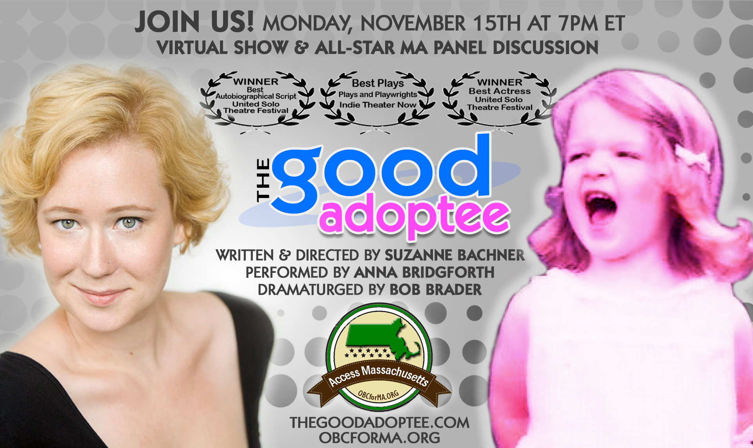
For Immediate Release

Award-Winning Show,
Live Panel Discussion Coming to a Screen
Near You on Nov. 15!

Access Massachusetts
Is Proud to Sponsor
This Powerful Evening

Media Contact:
Etta Lappen Davis
OBCforMA@gmail.com
978-853-2468

THE GOOD ADOPTEE
An Evening of Entertainment and Insights
To Raise Awareness about Adoptee Rights
During National Adoption Awareness Month

★★★★★ "A story is rarely so personal and it has a very healthy amount of laugh-out-loud-humour!”
– Sadie takes the Stage, London UK

“Incredible writing and performance! A powerful show that the entire world needs to see!”
– Suz Bednarz, birth mother, writingmywrongs.com

BOSTON, MA – Can you imagine not knowing your own identity? The Good Adoptee is the riveting, outrageous true story of award-winning playwright Suzanne Bachner’s search for her birth/first parents in the face of New York State's sealed records. Once she opens Pandora’s Box, can she find a way to integrate her dual identities and still remain “the Good Adoptee”?

Please join us for an evening of entertainment, education and engagement starting at 7 p.m. ET on Monday, November 15. Tickets for the show start at $11 and are on sale now at Eventbrite. A Zoom link will be sent to attendees before the event. For tickets and for more information go to: https://bit.ly/3mq8znT.

A livestreamed performance will be followed by discussion and Q&A with a panel that includes the play’s creative team and speakers who will give voice to the lived experiences of adopted persons, birth/first parents, adoptive parents, members of adoptive families and adoption professionals, all of whose lives have been profoundly affected by the issues raised in The Good Adoptee. The moderator will be Etta Lappen Davis, a longtime adoptee rights advocate and a leader of Access Massachusetts, which is working to restore the right of all adopted people to access their original birth certificates in the state.

This moving, highly acclaimed show has captivated audiences – notably including people who think they don’t have a connection to adoption – since it premiered in NYC's United Solo Theatre Festival, where it won awards for Best Autobiographical Script and Best Actress. The Good Adoptee is written and directed by Suzanne Bachner, performed by Anna Bridgforth and dramaturged by Bob Brader, with lighting and sound design by Katie Chai. The Good Adoptee has toured to the London International Fringe Festival and all over the U.S., including a 7-week 9-city Connecticut tour to support the vital and now successful legislative efforts of Access Connecticut as well as a Mini-Tour for Access Massachusetts.

The panel on November 15 will include:

Suzanne Bachner is the playwright and director of The Good Adoptee, an adoptee and adoptee rights advocate. As Artistic Director of NYC’s JMTC Theatre, Suzanne partners with amazing nonprofit organizations to raise funds and awareness through her theatrical work. JMTCTheatre.com

Bob Brader is the dramaturg of The Good Adoptee, an adoptee spouse, and an adoptee rights ally. Bob is an award-winning actor, writer, storyteller, and monologist and combines art and advocacy as the Executive Director of JMTC Theatre. BobBrader.com

Brenda Cotter is a lawyer and writer who has published many articles on adoption-related matters. She is the mother of two adult daughters who were adopted from China, and she is also an adoptee. Brenda has been advocating for adoptee access to their own vital records since the 1970s.

Claudia Corrigan D'Arcy is a birth mother who relinquished her first son in a Massachusetts traditional closed, voluntary, domestic adoption situation in 1987. Currently serving as the Associate Executive Director of Communications at the Adoptive and Foster Family Coalition of New York, she has been active in the online adoption community for over two decades, working as a birth parent advocate with a focus on ethics. She is extremely passionate about restoring the right of adult adoptees to their OBCs, and has worked on numerous campaigns across the nation to achieve that aim – including the successful campaign in New York State.

Max Corrigan / Gary Gainino / Gman was born and adopted in Massachusetts in 1987. Raised in a traditional closed adoption, he had no contact with his biological family for the first 17 years of his life, until his mother (Claudia Corrigan D’Arcy) reached out to him on MySpace in 2005. Since their first face-to-face meeting in 2007, Max has frequently joined his mother in advocating for adoptee rights, especially in the state of his birth where he is still denied access to his own OBC. No longer close with his immediate adoptive family, Max now resides with his birth mother and biological siblings in New York, where he enjoys gardening, chicken wrangling and a slight obsession with robot bodies.

Karen K. Greenberg is a founding member and past president of the Academy of Adoption and Assisted Reproduction Attorneys (AAAA). Her passion has always been to level the playing field in every aspect of “best interests of children,” be it in adoption, paternity or divorce matters. In addition to her advocacy for adoptee rights, her past activities have included campaigning for a National Responsible Father Registry, with the aim of requiring states to give notice of a pending termination of parental rights so men have the opportunity to parent their own children. The American Bar Association recently published Contested Adoption, A Lawyer’s Guide to All Sides, written by Karen and three of her AAAA colleagues, again motivated to level the playing field by addressing the law’s applicability to each member of the triad.

Sarah Elizabeth Neville is a PhD candidate at the Boston College School of Social Work, where she studies global child welfare. Sarah's parents adopted two children from China when she was a teenager, inspiring her academic focus on adoption, foster care and family preservation around the world. Her dissertation focuses on children in Kenya who have been reunified with their families after living in orphanages. Sarah also has a biological half-sister who was placed in a closed adoption before she was born and for whom Sarah's family (unfortunately) is still searching.

Jean Strauss is a bestselling NYTimes author and award-winning filmmaker who has been documenting the experience of adoptees and the adoption constellation for over three decades. She is an activist and an adopted person whose work has assisted in the passage of access legislation in several states and her book, "Birthright: the Guide to Search and Reunion" has been in print from Penguin since 1994. Revised E-Book and Audible versions are being released in December. Jean is currently cutting her third feature film, "Citizen Adoptee" (due out in 2022); her first two features aired on PBS. All 56 of her adoption films are available for free viewing at: https://vimeo.com/channels/adopteefilmchannel.

For more information about the play, please visit www.TheGoodAdoptee.com.
For more information about Access Massachusetts, please visit: www.OBCforMA.org

